Practical 2: State Management and Routing in React

Objective:- | To implement reactive state management using useState and multi-page navigation using React Router in the existing portfolio application.
Problem Statement:- | • Extend the portfolio application from Practical 1 by adding React  Router.  • Implement a navigation bar with at least 3 routes: Home, Projects, and  Contact.  • Each route must render a distinct component without a full page reload.  • Add at least 2 useState variables used meaningfully one for toggling UI  visibility and one for managing a form input on the Contact page.  • The Contact page must include a controlled input that captures and  displays user input in real time.
Implementation:- | Navbar:  Projects:  import { useEffect, useMemo, useState } from 'react'  import { Search } from 'lucide-react'  import { FiGithub } from 'react-icons/fi'  import { profile } from '../../utils/data'  import Section from '../ui/Section'  import Reveal from '../ui/Reveal'  import Spinner from '../ui/Spinner'  import ErrorMessage from '../ui/ErrorMessage'  import RepoList from '../ui/RepoList'  const GITHUB_API_URL = `https://api.github.com/users/${profile.githubUsername}/repos`  const Projects = () => {  const [repos, setRepos] = useState([])  const [loading, setLoading] = useState(true)  const [error, setError] = useState(null)  const [query, setQuery] = useState('')  const [attempt, setAttempt] = useState(0)  useEffect(() => {  let ignore = false  setLoading(true)  setError(null)  fetch(`${GITHUB_API_URL}?per_page=30&sort=updated`)  .then((res) => {  if (!res.ok) throw new Error(`GitHub API responded with ${res.status}`)  return res.json()  })  .then((data) => {  if (!ignore) setRepos(data)  })  .catch((err) => {  if (!ignore) setError(err.message)  })  .finally(() => {  if (!ignore) setLoading(false)  })  return () => {  ignore = true  }  }, [attempt])  const sorted = useMemo(  () =>  [...repos].sort(  (a, b) => (b.stargazers_count ?? 0) - (a.stargazers_count ?? 0)  ),  [repos]  )  const filtered = useMemo(  () =>  sorted.filter((repo) =>  repo.name.toLowerCase().includes(query.trim().toLowerCase())  ),  [sorted, query]  )  return (  <Section  id="projects"  eyebrow="Projects"  title="Open-source work"  description="A live list of my public repositories, fetched straight from the GitHub API."  >  <Reveal>  <div className="mb-6 flex flex-col items-start justify-between gap-4 sm:flex-row sm:items-center">  <p className="inline-flex flex-wrap items-center gap-1.5 text-sm text-muted">  <FiGithub className="size-4 text-bronze" />  <span>  {loading  ? 'Fetching from GitHub…'  : error  ? 'Showing GitHub data'  : `${filtered.length} of ${repos.length} repositories${  query ? ' matching your search' : ''  }`}  </span>  </p>  <div className="relative w-full sm:w-72">  <Search className="absolute top-1/2 left-3.5 size-4 -translate-y-1/2 text-muted" />  <input  type="search"  value={query}  onChange={(e) => setQuery(e.target.value)}  placeholder="Filter repositories by name…"  aria-label="Filter repositories by name"  className="w-full rounded-xl border border-line-strong bg-surface py-2.5 pr-4 pl-10 text-sm text-ink shadow-[inset_0_1px_3px_rgba(60,45,20,0.08)] outline-none transition-all duration-200 placeholder:text-muted focus:border-bronze focus:bg-parchment focus:ring-2 focus:ring-bronze/20"  />  </div>  </div>  </Reveal>  {loading ? (  <Reveal>  <Spinner />  </Reveal>  ) : error ? (  <Reveal>  <ErrorMessage  message={error}  onRetry={() => setAttempt((n) => n + 1)}  />  </Reveal>  ) : (  <Reveal>  <RepoList repos={filtered} hasRepos={repos.length > 0} />  </Reveal>  )}  </Section>  )  }  export default Projects  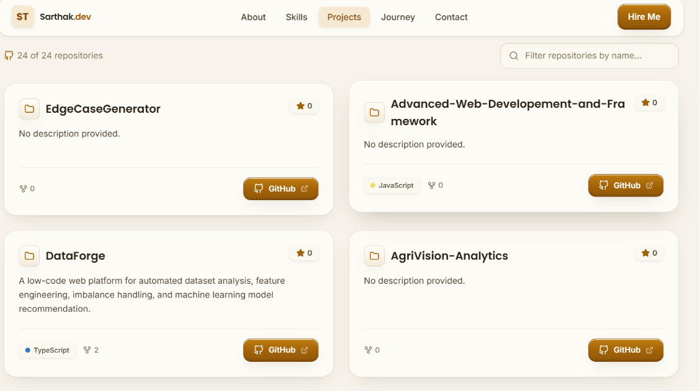  Contact:  import { useState } from 'react'  import { Send, Mail, Phone, CheckCircle2 } from 'lucide-react'  import { FiGithub, FiLinkedin } from 'react-icons/fi'  import { profile, socials } from '../../utils/data'  import Section from '../ui/Section'  import Reveal from '../ui/Reveal'  import Button from '../ui/Button'  const contactCards = [  { icon: Mail, label: 'Email', value: profile.email, href: `mailto:${profile.email}` },  { icon: Phone, label: 'Phone', value: profile.phone, href: `tel:+919601039375` },  { icon: FiGithub, label: 'GitHub', value: '@Talaviya-Sarthak', href: profile.github },  { icon: FiLinkedin, label: 'LinkedIn', value: 'in/sarthak-talaviya', href: profile.linkedin },  ]  const inputClass =  'w-full rounded-xl border border-line-strong bg-surface px-4 py-3 text-sm text-ink shadow-[inset_0_1px_3px_rgba(60,45,20,0.08)] outline-none transition-all duration-200 placeholder:text-muted focus:border-bronze focus:bg-parchment focus:ring-2 focus:ring-bronze/20'  const Contact = () => {  const [form, setForm] = useState({ name: '', email: '', message: '' })  const [status, setStatus] = useState('idle')  const update = (key) => (e) => setForm((f) => ({ ...f, [key]: e.target.value }))  const onSubmit = (e) => {  e.preventDefault()  const mailto = `mailto:${profile.email}?subject=Portfolio enquiry from ${encodeURIComponent(  form.name || 'a visitor'  )}&body=${encodeURIComponent(form.message)}`  window.location.href = mailto  setStatus('sent')  setForm({ name: '', email: '', message: '' })  window.setTimeout(() => setStatus('idle'), 5000)  }  return (  <Section  id="contact"  eyebrow="Contact"  title="Let's build something"  description="Have a role, a project or an idea? My inbox is always open — I usually reply within a day."  >  <div className="grid gap-8 lg:grid-cols-[0.9fr_1.1fr] lg:gap-10">  <div className="flex flex-col gap-5">  {contactCards.map((card, idx) => (  <Reveal key={card.label} delay={idx * 0.07}>  <a  href={card.href}  target={card.href.startsWith('mailto') ? undefined : '_blank'}  rel="noreferrer"  className="surface-raised group flex items-center gap-4 p-5 transition-all duration-300 hover:-translate-y-1 hover:shadow-hover"  >  <span className="btn-secondary inline-flex shrink-0 rounded-xl p-3">  <card.icon className="size-5 text-bronze-deep" />  </span>  <span>  <span className="block text-xs font-semibold tracking-wide text-muted uppercase">  {card.label}  </span>  <span className="block text-sm font-medium text-ink transition-colors group-hover:text-bronze-deep">  {card.value}  </span>  </span>  </a>  </Reveal>  ))}  <Reveal delay={0.25}>  <div className="surface-raised p-5">  <p className="text-sm font-semibold text-ink">Prefer quick chat?</p>  <p className="mt-1 text-sm text-muted">  Find me on the platforms below, or drop a message through the form.  </p>  <div className="mt-4 flex flex-wrap gap-2">  {socials.map((s) => (  <a  key={s.label}  href={s.href}  target={s.href.startsWith('mailto') ? undefined : '_blank'}  rel="noreferrer"  className="btn-secondary inline-flex items-center gap-2 rounded-xl px-3.5 py-2 text-xs font-semibold transition-all duration-200 hover:-translate-y-0.5"  >  {s.label}  </a>  ))}  </div>  </div>  </Reveal>  </div>  <Reveal delay={0.1}>  <form onSubmit={onSubmit} className="surface-raised p-6 sm:p-8">  <h3 className="font-display text-lg font-semibold text-ink">Send me a message</h3>  <p className="mt-1 text-sm text-muted">  This opens your email client with the message pre-filled.  </p>  <div className="mt-6 grid gap-4 sm:grid-cols-2">  <div>  <label htmlFor="name" className="mb-1.5 block text-xs font-semibold text-ink-soft">  Name  </label>  <input  id="name"  type="text"  required  value={form.name}  onChange={update('name')}  placeholder="Jane Doe"  className={inputClass}  />  </div>  <div>  <label htmlFor="email" className="mb-1.5 block text-xs font-semibold text-ink-soft">  Email  </label>  <input  id="email"  type="email"  required  value={form.email}  onChange={update('email')}  placeholder="jane@company.com"  className={inputClass}  />  </div>  </div>  <div className="mt-4">  <label htmlFor="message" className="mb-1.5 block text-xs font-semibold text-ink-soft">  Message  </label>  <textarea  id="message"  required  rows={5}  value={form.message}  onChange={update('message')}  placeholder="Tell me about your project or opportunity…"  className={`${inputClass} resize-none`}  />  </div>  <div className="mt-6 flex items-center gap-4">  <Button as="button" type="submit" variant="primary">  <Send className="size-4" />  Send Message  </Button>  {status === 'sent' && (  <p className="inline-flex items-center gap-1.5 text-sm font-medium text-tick">  <CheckCircle2 className="size-4" />  Opening your mail client…  </p>  )}  </div>  </form>  </Reveal>  </div>  </Section>  )  }  export default Contact  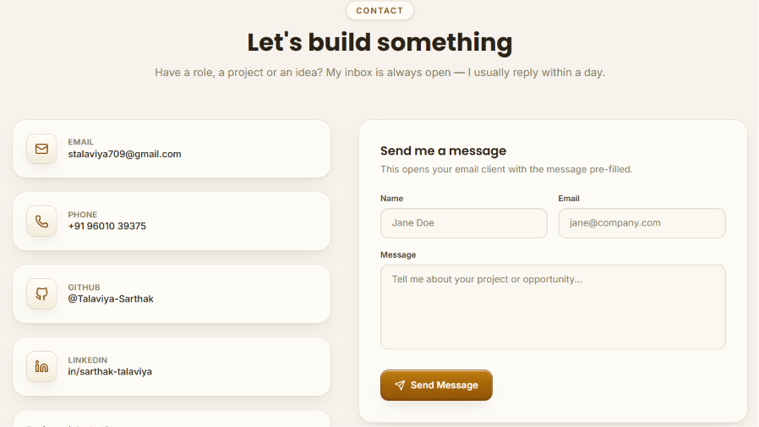  404 Error  import { Link } from 'react-router-dom'  import { motion, useReducedMotion } from 'framer-motion'  import { Compass, Home, ArrowLeft } from 'lucide-react'  import Navbar from '../components/Navbar'  import Footer from '../components/Footer'  const NotFound = () => {  const reduceMotion = useReducedMotion()  return (  <>  <Navbar />  <main className="relative flex min-h-[80vh] items-center justify-center px-5 pt-24 pb-16 sm:pt-28">  <div className="mx-auto w-full max-w-3xl text-center">  <motion.div  initial={{ opacity: 0, y: reduceMotion ? 0 : 24 }}  animate={{ opacity: 1, y: 0 }}  transition={{ duration: 0.65, ease: [0.22, 1, 0.36, 1] }}  >  <span className="mb-6 inline-flex items-center gap-2 rounded-full border border-line-strong bg-parchment px-3.5 py-1.5 text-xs font-semibold tracking-[0.14em] uppercase text-bronze-deep shadow-soft">  <Compass className="size-3.5" />  Error 404  </span>  <div className="well mx-auto mb-6 inline-flex items-center justify-center px-8 py-5 sm:px-12">  <span className="font-display text-7xl font-bold tracking-tight text-bronze sm:text-8xl">  4  <span className="mx-1 inline-block size-10 rounded-xl border border-line-strong bg-cream align-baseline shadow-well sm:size-14" />  4  </span>  </div>  <h1 className="font-display text-3xl font-bold text-ink sm:text-4xl">  This page drifted off the map  </h1>  <p className="mx-auto mt-4 max-w-xl text-sm leading-relaxed text-muted sm:text-base">  The page you&apos;re looking for doesn&apos;t exist or was moved.  Let&apos;s get you back to somewhere useful.  </p>  <div className="mt-8 flex flex-col items-center justify-center gap-3 sm:flex-row">  <Link  to="/"  className="btn-primary inline-flex cursor-pointer items-center justify-center gap-2 rounded-xl px-5 py-3 text-sm font-semibold transition-all duration-200 select-none hover:-translate-y-0.5"  >  <Home className="size-4" />  Back to Home  </Link>  <Link  to="/#about"  className="btn-secondary inline-flex cursor-pointer items-center justify-center gap-2 rounded-xl px-5 py-3 text-sm font-semibold transition-all duration-200 select-none hover:-translate-y-0.5"  >  <ArrowLeft className="size-4" />  About Me  </Link>  </div>  </motion.div>  </div>  </main>  <Footer />  </>  )  }  export default NotFound  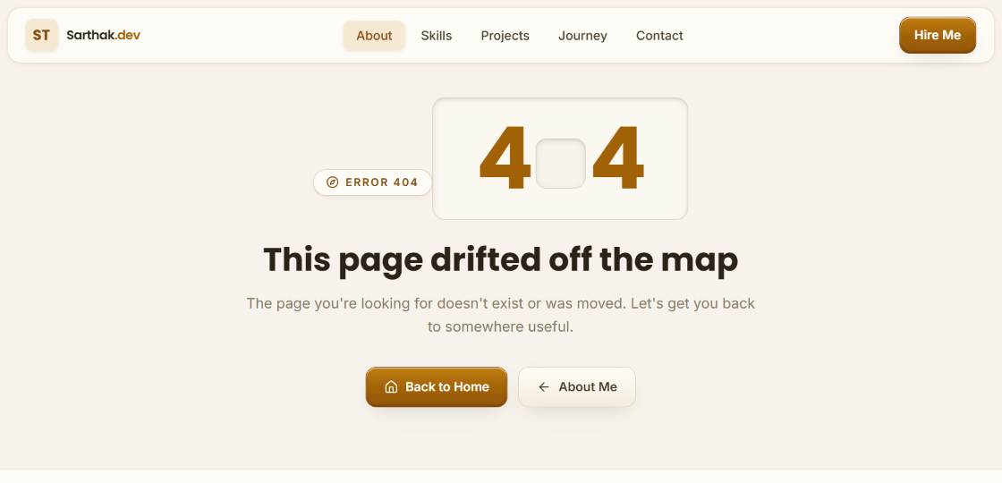
Outcome | Students will be able to implement client-side routing with React Router  and manage dynamic UI state using useState, resulting in a multi-page  application without full page reloads.

